FOCP C Programming Assignment
Question 1: Read from STDIN, Write to STDOUT
Platform: HackerEarth
Programming Language: C
Problem Statement URL:
https://www.hackerearth.com/practice/basic-programming/input-output/basics-of-input-output/practice-problems/algorithm/io-exercise/
Problem Statement
Read an integer N and a string S from standard input. Print N multiplied by 2 on the first line and the same string S on the second line.
Source Code
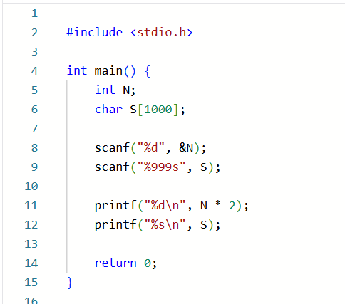
Output
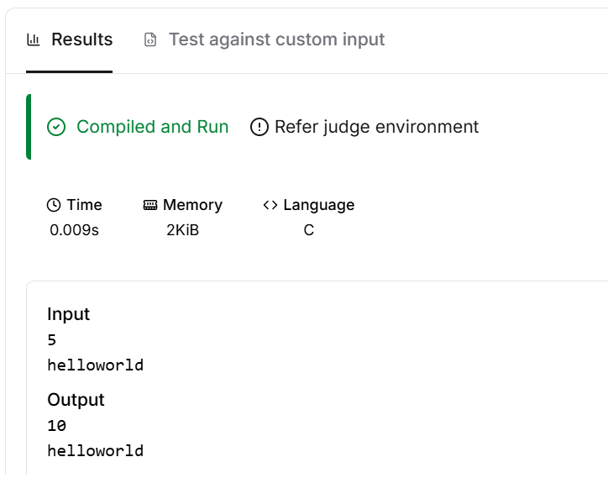
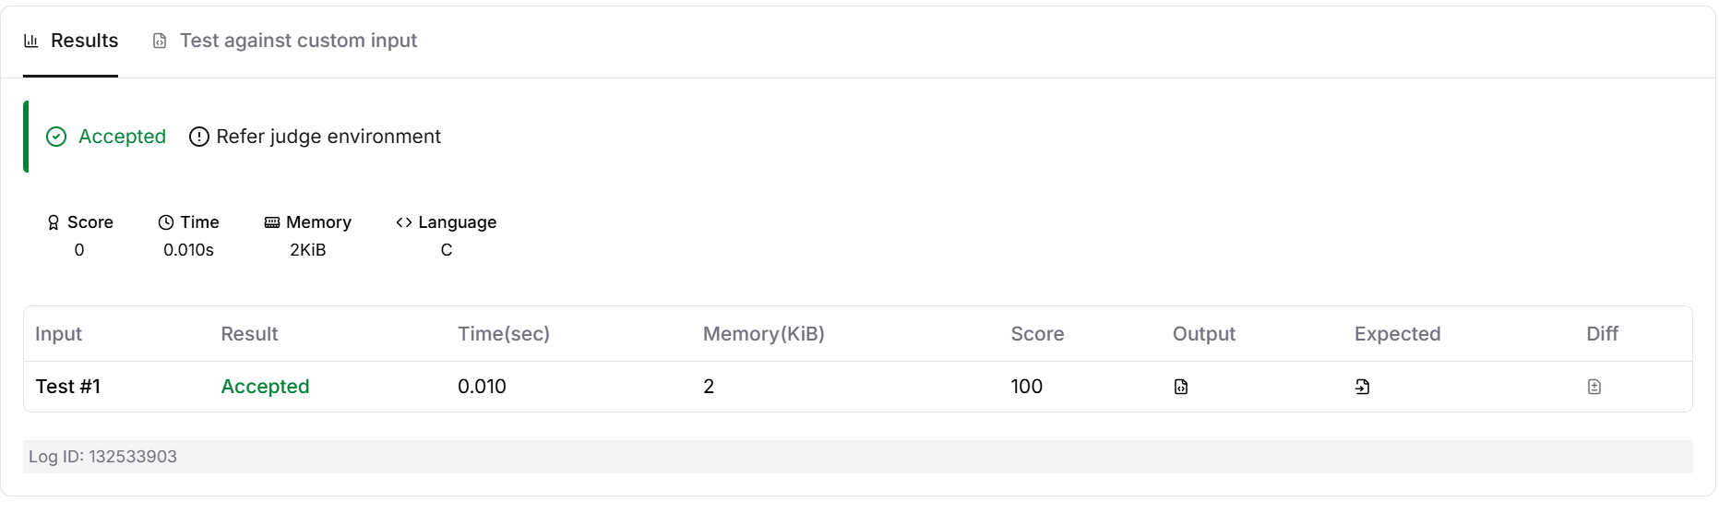Result
The program was executed successfully, and the submission was accepted on HackerEarth.

